
Greenwood College
Year 12 Applications
Test 2 2020
Resource-Free

Name…………………………………………………………………………………………

No calculators nor notes allowed. Formula sheet allowed.
18 mark total. 20 minute time limit

Question 1 [4 marks: 2, 2]

A number sequence is an arithmetic progression. The third term is 13 and the seventh term is 33.

(a) Determine the common difference.

(b) Find the first term.

Question 2 [5 marks: 3, 2]

A geometric sequence has a common ratio of -3. The fifth term in the sequence is 405.
- Find the first term in the sequence

- Write down the recurrence relation that describes this sequence.

Question 3 [6 marks: 2, 2, 2]

Below are four consecutive numbers of an arithmetic sequence. The middle two numbers are missing

…… , 24, ……. , ……. , 81, …..

a) What are the two missing numbers?

b) If the first term T₁ is 24, find the general rule for T_{n.}

c) Now suppose the K^{th} term T_{k} is 24. Find the general rule for T_{n.}

Question 4 [3 marks]

The number sequence $4000, $4120, $4240, $4360,… represents the current value of Mary’s investment at the end of each year.

What type of interest has been used by the financial institution to calculate the interest? Explain your choice.

Greenwood College
Year 12 Applications
Test 2 2020
Resource-Allowed

Name…………………………………………………………………………………………

Formula sheet, one A4 page double-sided of notes and calculators allowed.

35 mark total. 35 minute time limit

Question 7 [7 marks: 3, 2, 2]

A lakes complex is thinking of allowing some very limited fishing to occur in order to keep the population of fish in the lakes under control. It is thought that the current population of fish is approximately 1500 and that left uncontrolled this will increase at approximately 18% per year. If limited fishing is allowed, one suggestion is to allow approximately 400 fish to be caught every 12 months.

(a) Write a recursive formula, in terms of P, to represent the number of fish left in the lakes after 400 have been caught.

(b) How many fish will be in the pond after the fifth lot of fish are caught?

(c) How many fish need to be caught every year to maintain the fish population at a constant level?

Question 8 [11 marks: 2, 3, 2, 2, 2]

Helen borrows $15000 at a flat rate of 6% per annum. The loan is to be repaid over 3 years.

(a) Find the total interest paid on this loan.

(b) Calculate the monthly repayment.

(c) Write a explicit formula to show the how much Helen owes after the nth month.

(d) After making 10 monthly repayments (using part b), Helen is able to increase her repayments to $600 per month. We can assume no penalty for early repayment.

(i) How long will it take her to pay off the loan?

(ii) What is the amount of the her last repayment?

Question 9 [6 marks: 3, 3]

Mary plans to travel overseas in October 2023 so she decides to save for her trip by making monthly deposits of $500 into an investment account. This account accrues interest at the rate of 5% p.a. compounded monthly. Mary opens this account on the 1st November 2020 with a deposit of $500 with all future deposits being made on the first day of the month.

(a) Write a recursive formula to show the balance at the beginning of each month.

(b) How much will be in this account on the 30th September 2023?

Question 10 [8 marks: 1, 3, 2, 2]

A fish farm is stocked with 4000 fish. The owners plan to sell 20% of the fish stock throughout the year and then to re-stock the farm with an extra 200 fish at the end of the year. The fish stock F_{n}, at the start of year n can be modelled by
F_{n+1} = 0.80F_{n} + 200, where F₀ = 4000

(a) Explain the significance of the 0.8 in the model.

(b) Graph the amount of fish for the first 6 years.

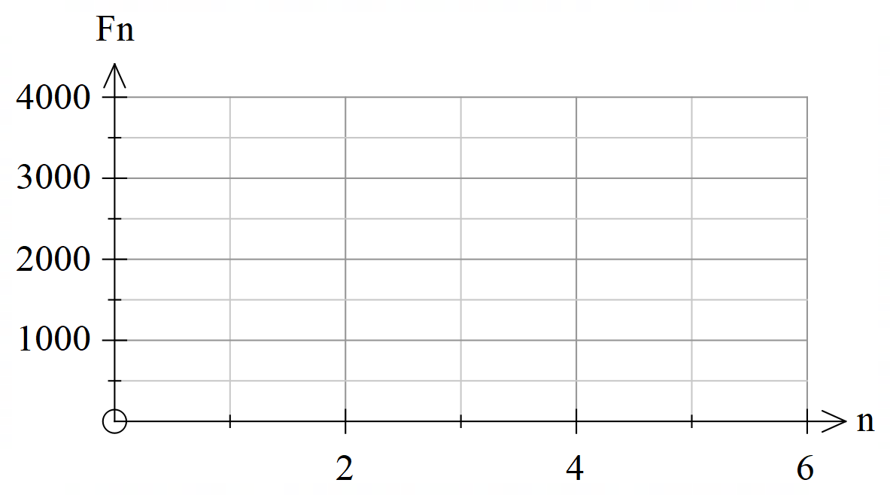

(c) Comment on how the size of the fish stock is changing over the first 6 years.

(d) Show, with working, how the size of the fish stock will approach 1000 in the long run.

